**CLOUD COMPUTING LAB EXPERIMENTS**

**EXPERIMENT 1:**

**1.** Create a simple cloud software application and provide it as a service using any Cloud Service Provider to demonstrate Software as a service(Saas).

**AIM:** To create a simple cloud software application and provide it as a service using

any Cloud Service Provider to demonstrate Software as a service (Saas).

**PROCEDURE:**

STEP 1: Login to Zoho Creator

STEP 2: Click Create New Application → From Scratch.

STEP 3: Name your app (example: Student Feedback System).

STEP 4:Create a Form (for data input):

Field 1: Name (Single Line)

Field 2: Email (Email)

Field 3: Feedback (Multi-line text)

STEP 5: Create a Report (Table View) → This will automatically show submitted feedback.

STEP 6: Click Access → Share → Public Link to make it usable by anyone.

STEP 7:Open the link in a browser → Fill and submit the form → Data gets stored and shown in reports.

**OUTPUT:**

ONLINE STUDENT REGISTRATION FORM:

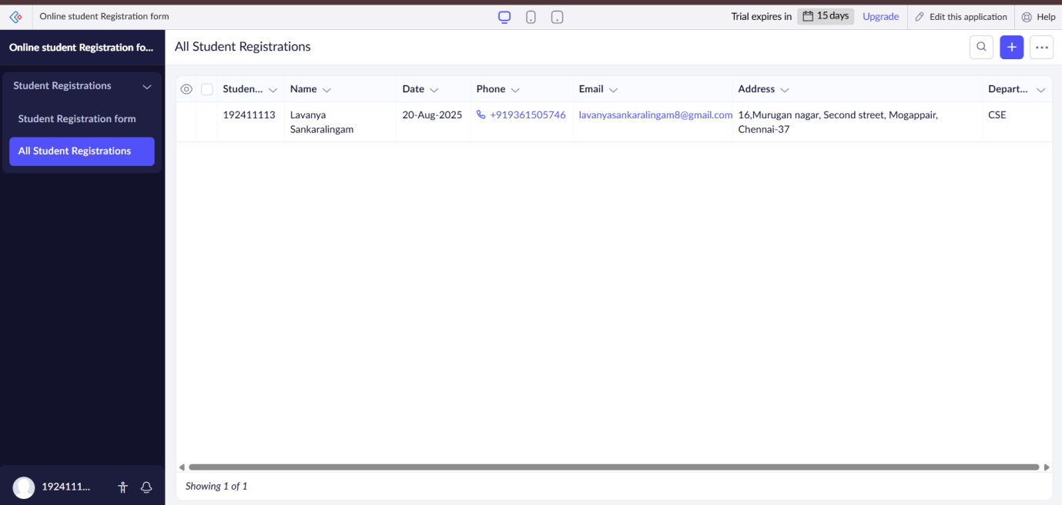

**RESULT**

A cloud application was created and deployed successfully , demonstrating the Software as a Service (SaaS) model.

**EXPERIMENT 2:**

**2.** Create a simple cloud software application for Flight Reservation System using any Cloud Service Provider to demonstrate SaaS.

**AIM:**

To create a simple cloud software application for Flight Reservation System using any Cloud Service Provider to demonstrate SaaS.

**PROCEDURE:**

STEP 1: Login to Zoho Creator

STEP 2: Click Create New Application → From Scratch.

STEP 3: Name your app (example: Student Feedback System).

STEP 4:Create a Form (for data input):

Field 1: Name (Single Line)

Field 2: Email (Email)

Field 3: Feedback (Multi-line text)

STEP 5: Create a Report (Table View) → This will automatically show submitted feedback.

STEP 6: Click Access → Share → Public Link to make it usable by anyone.

STEP 7:Open the link in a browser → Fill and submit the form → Data gets stored and shown in reports.

**OUTPUT:**

FLIGHT DETAILS

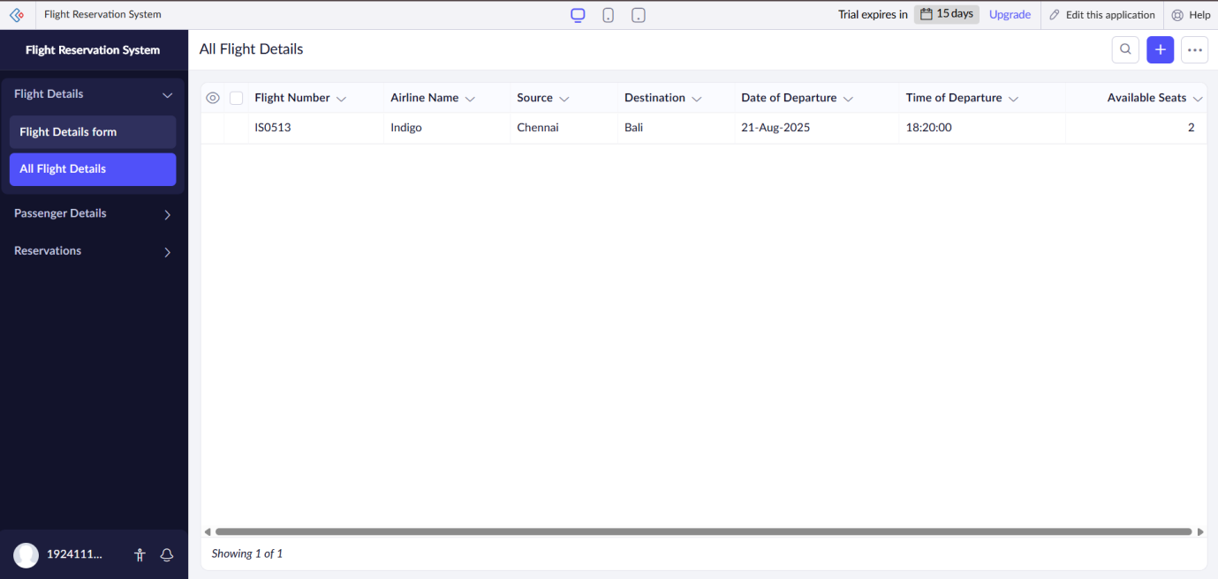

PASSENGER DETAILS

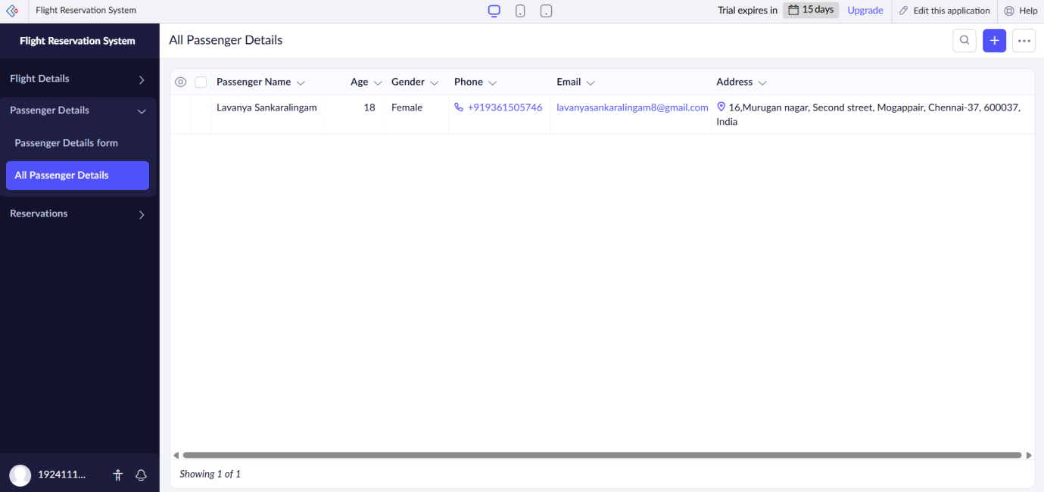

RESERVATION FORM

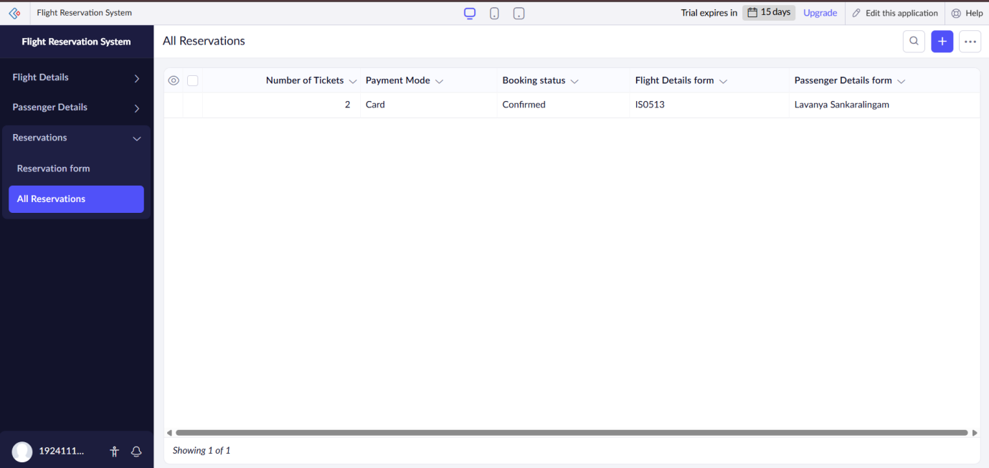

**RESULT:**

A cloud application for Flight Reservation System was created and deployed successfully, demonstrating the Software as a Service (SaaS) model.

**EXPERIMENT 3:**

**3.** Create a simple cloud software application for Property Buying & Rental

process (In Chennai city) using any Cloud Service Provider to demonstrate

SaaS.

**AIM:** To create a simple cloud software application for Property Buying & Rental

process (In Chennai city) using any Cloud Service Provider to demonstrate

SaaS.

**PROCEDURE:**

STEP 1: Login to Zoho Creator

STEP 2: Click Create New Application → From Scratch.

STEP 3: Name your app (example: Student Feedback System).

STEP 4:Create a Form (for data input):

Field 1: Name (Single Line)

Field 2: Email (Email)

Field 3: Feedback (Multi-line text)

STEP 5: Create a Report (Table View) → This will automatically show submitted feedback.

STEP 6: Click Access → Share → Public Link to make it usable by anyone.

STEP 7:Open the link in a browser → Fill and submit the form → Data gets stored and shown in reports.

**OUTPUT:**

PROPERTY FORM:

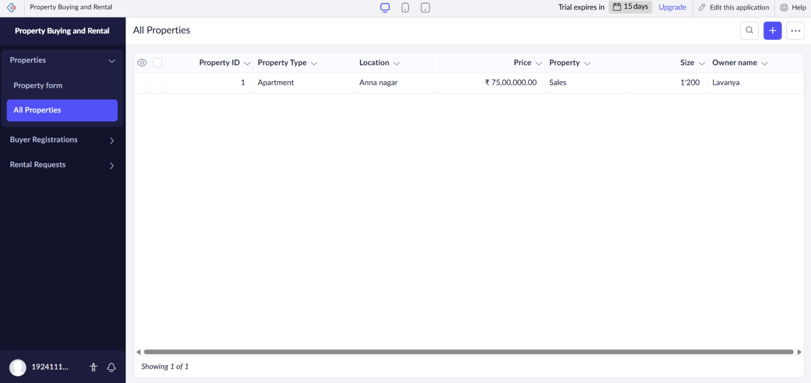

BUYER FORM:

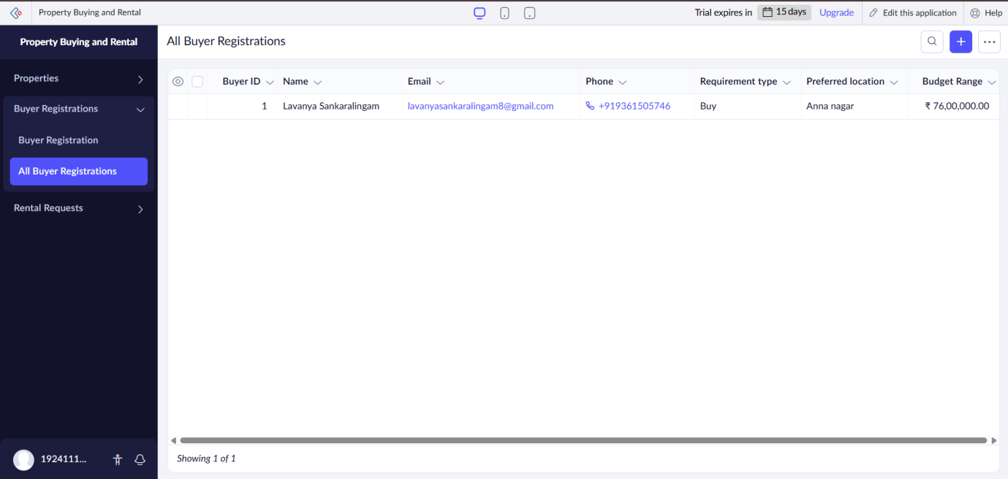

RENTAL REQUEST:

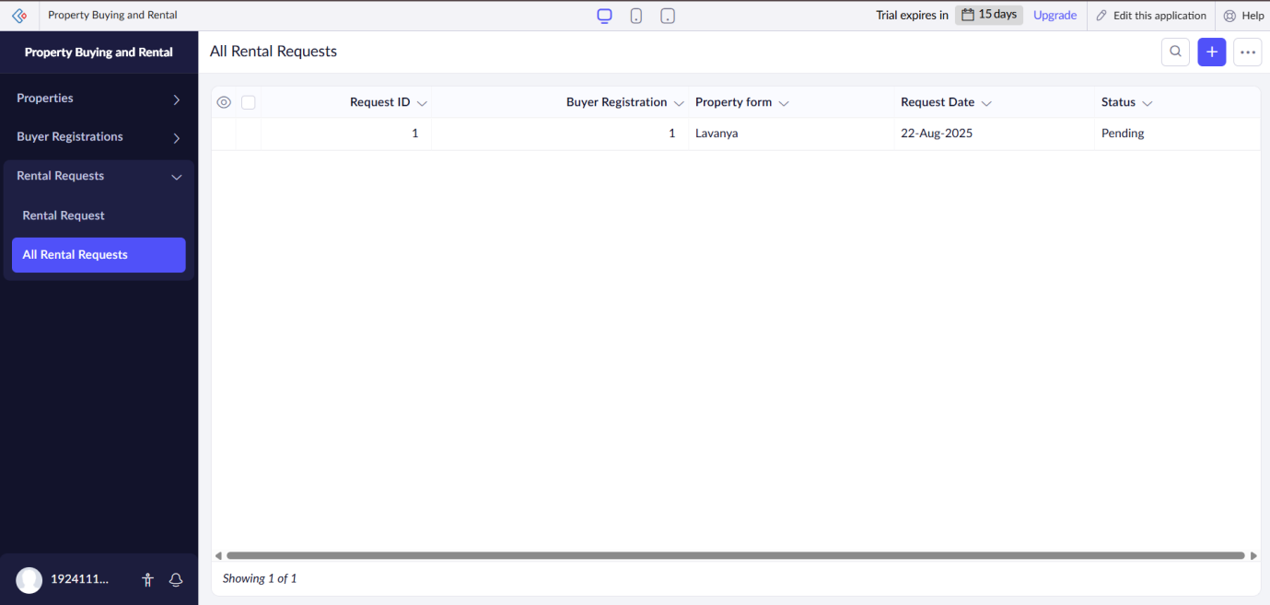

**RESULT:**

A cloud application for Property Buying and Rental process(in Chennai)was created and deployed successfully, demonstrating the Software as a Service (SaaS) model.

**EXPERIMENT 4:**

**4**. Create a simple cloud software application for Car Booking Reservation System

using any Cloud Service Provider to demonstrate SaaS.

**AIM:** To create a simple cloud software application for Car Booking Reservation System using any Cloud Service Provider to demonstrate SaaS.

**PROCEDURE:**

STEP 1: Login to Zoho Creator

STEP 2: Click Create New Application → From Scratch.

STEP 3: Name your app (example: Student Feedback System).

STEP 4:Create a Form (for data input):

Field 1: Name (Single Line)

Field 2: Email (Email)

Field 3: Feedback (Multi-line text)

STEP 5: Create a Report (Table View) → This will automatically show submitted feedback.

STEP 6: Click Access → Share → Public Link to make it usable by anyone.

STEP 7:Open the link in a browser → Fill and submit the form → Data gets stored and shown in reports.

**OUTPUT:**

CAR DETAILS FORM:

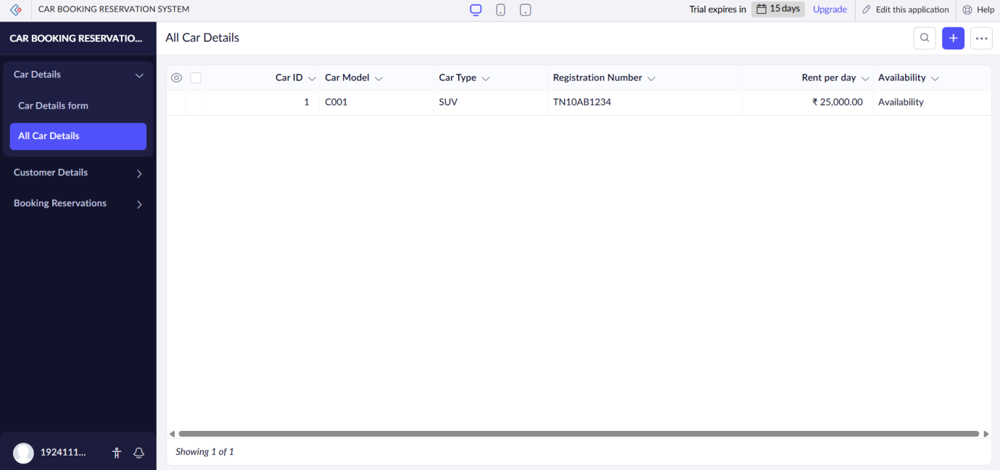

CUSTOMER DETAILS FORM:

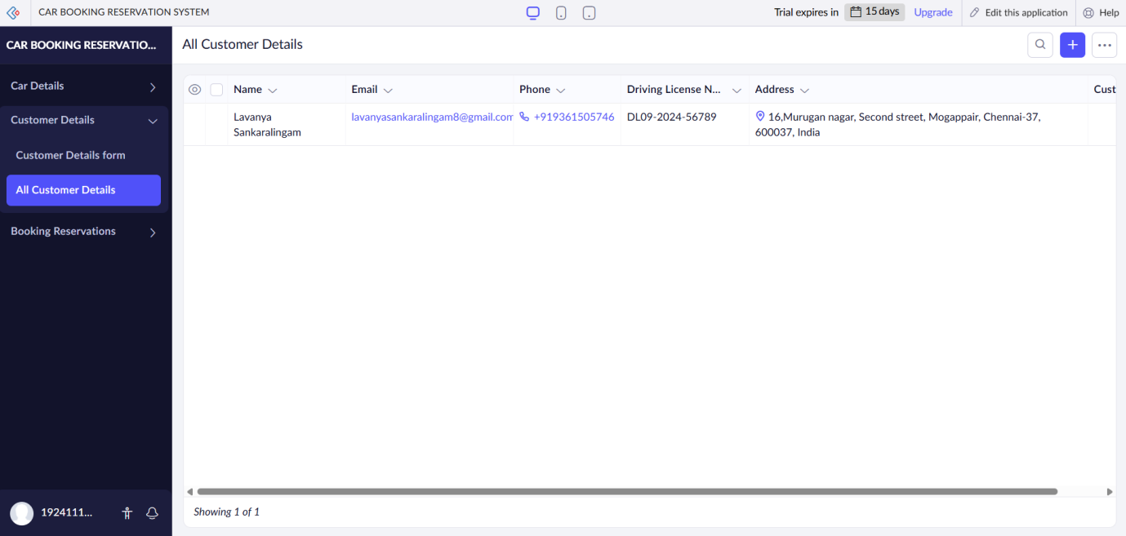

BOOKING RESERVATION FORM:

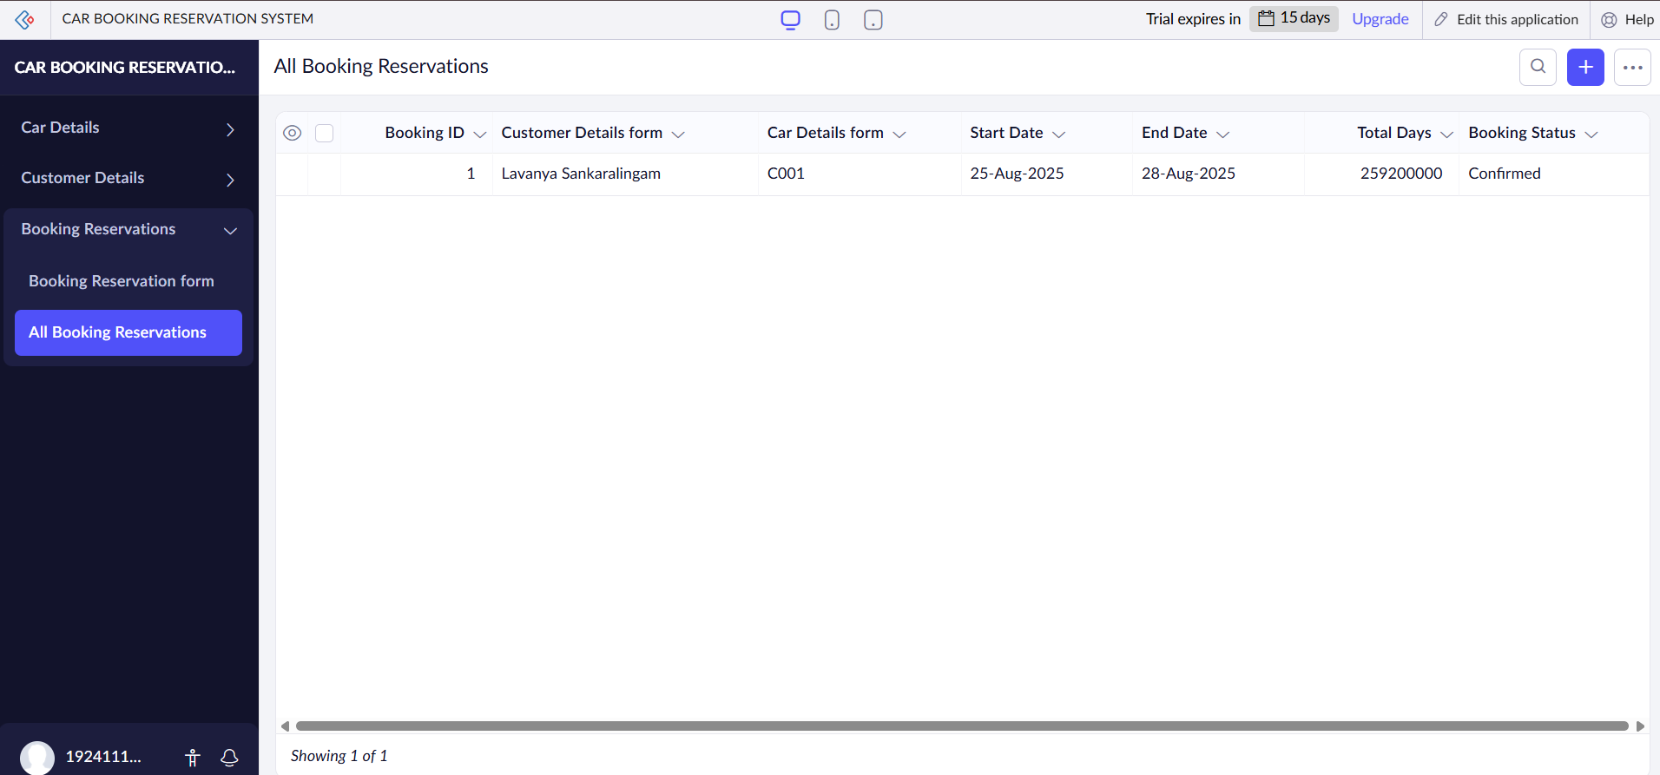

**RESULT:**

A cloud application for Car Booking Reservation System was created and deployed successfully, demonstrating the Software as a Service (SaaS) model.

**EXPERIMENT 5:**

**5.** Create a simple cloud software application for Library book reservation

system for SIMATS library using any Cloud Service Provider to demonstrate

SaaS.

**AIM:** To create a simple cloud software application for Library book reservation

system for SIMATS library using any Cloud Service Provider to demonstrate

SaaS.

**PROCEDURE:**

STEP 1: Login to Zoho Creator

STEP 2: Click Create New Application → From Scratch.

STEP 3: Name your app (example: Student Feedback System).

STEP 4:Create a Form (for data input):

Field 1: Name (Single Line)

Field 2: Email (Email)

Field 3: Feedback (Multi-line text)

STEP 5: Create a Report (Table View) → This will automatically show submitted feedback.

STEP 6: Click Access → Share → Public Link to make it usable by anyone.

STEP 7:Open the link in a browser → Fill and submit the form → Data gets stored and shown in reports.

**OUTPUT:**

BOOK DETAILS FORM:



STUDENT DETAILS FORM:

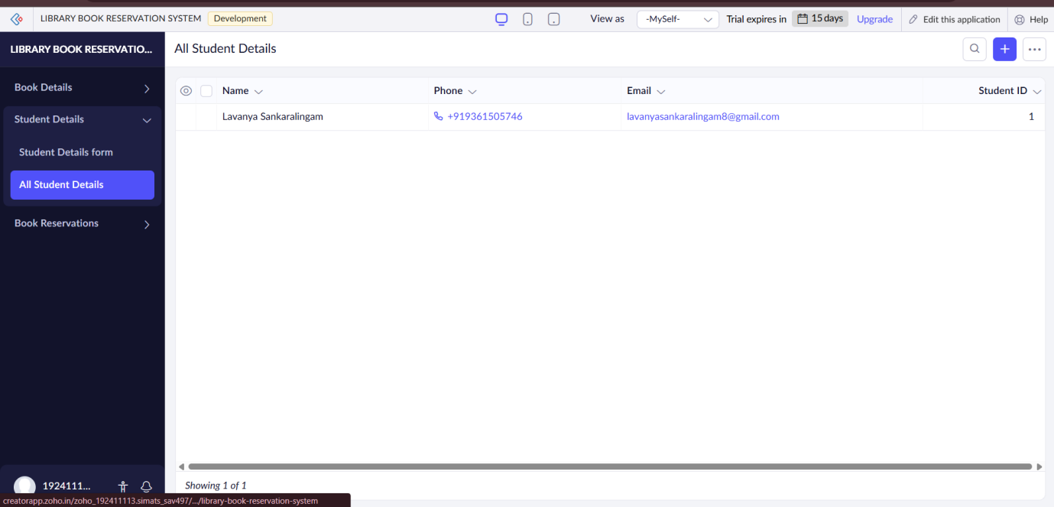

BOOK RESERVATION FORM:

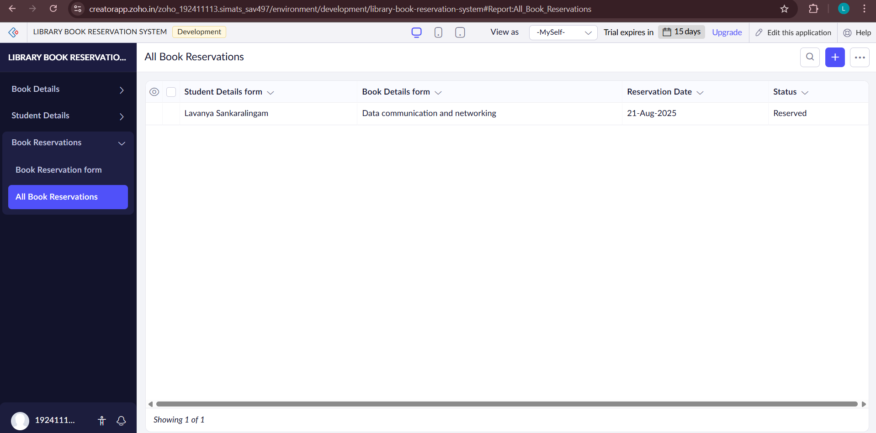

**RESULT:**

A cloud application for Library Book Reservation System for SIMATS Library was created and deployed successfully, demonstrating the Software as a Service (SaaS) model.